# Assignment: Python Programming for GUI Development

Name: G. Siva Dhanashekar

Register Number: 192311318

Department: CSE

Date of Submission:26/08/2024

Problem 1: Inventory Management System Optimization

**Scenario:**

You are developing an inventory management system for a business to optimize inventory tracking, manage reorders, and generate reports. The system should handle various inventoryrelated tasks and provide insights based on the data.

**Tasks:**

You are developing an inventory management system for a business to optimize inventory tracking, manage reorders, and generate reports. The system should handle various inventoryrelated tasks and provide insights based on the data.

**Tasks:**

1. Create a diagram to illustrate how data flows between the user, the Python application, and the database.
2. Build an application that integrates with a database (e.g., SQLite or MySQL) to manage inventory data.
3. Allow users to input, update, and view inventory data.

Provide functionality to check stock levels, reorder points, and generate reports.

1. Implement logic to suggest reorders based on stock levels and reorder points.

**Deliverables:**

* Data flow diagram illustrates how the system interacts with the database and the user..
* Provide pseudocode and Python code for the system.
* Explain the API integration (if applicable), methods used to manage and display inventory data, and any potential improvements
* Discuss any assumptions made during development and potential areas for improvement.

**Solution:**

**Inventory Management System Optimization**

**1.Data Flow Diagram:**

Python

Application

Data Base

User

**2. Implementation:**

import sqlite3 import datetime def connect_db():

return sqlite3.connect('inventory.db')

# Step 2: Create tables def create_tables(conn): cursor = conn.cursor() cursor.execute('''CREATE TABLE IF NOT EXISTS

inventory

(id INTEGER PRIMARY KEY, item_name TEXT, stock_level INTEGER, reorder_level INTEGER, last_updated DATE)''')

conn.commit()

def add_item(conn, item_name, stock_level, reorder_level): cursor = conn.cursor() cursor.execute('''INSERT INTO inventory (item_name,

stock_level, reorder_level, last_updated)

VALUES (?, ?, ?, ?)''', (item_name, stock_level, reorder_level, datetime.date.today())) conn.commit()

def update_stock(conn, item_id, new_stock_level): cursor = conn.cursor() cursor.execute('''UPDATE inventory

SET stock_level = ?, last_updated = ?

WHERE id = ?''', (new_stock_level, datetime.date.today(), item_id)) conn.commit()

def fetch_stock(conn): cursor = conn.cursor() cursor.execute('''SELECT * FROM inventory''') return cursor.fetchall()

def check_reorder(conn): cursor = conn.cursor() cursor.execute('''SELECT * FROM inventory WHERE

stock_level < reorder_level''') return cursor.fetchall()

def generate_report(conn): stock_data = fetch_stock(conn) for item in stock_data:

print(f"Item: {item[1]}, Stock Level: {item[2]}, Reorder

Level: {item[3]}, Last Updated: {item[4]}") print("\nItems to Reorder:") items_to_reorder = check_reorder(conn) for item in items_to_reorder:

print(f"Item: {item[1]}, Stock Level: {item[2]}, Reorder Level: {item[3]}") conn = connect_db() create_tables(conn) add_item(conn, 'Widget A', 50, 10) add_item(conn, 'Widget B', 20, 5)

update_stock(conn, 1, 8) # Assuming item with id=1 is

'Widget A' generate_report(conn) conn.close()

**3.Display the Current Inventory Information:**

Item: Widget A, Stock Level: 8, Reorder Level: 10, Last Updated: 2024-08-25 Item: Widget B, Stock Level: 20, Reorder Level: 5, Last Updated: 2024-08-25

Items to Reorder: Item: Widget A, Stock Level: 8, Reorder Level: 10

**4.User Input:**

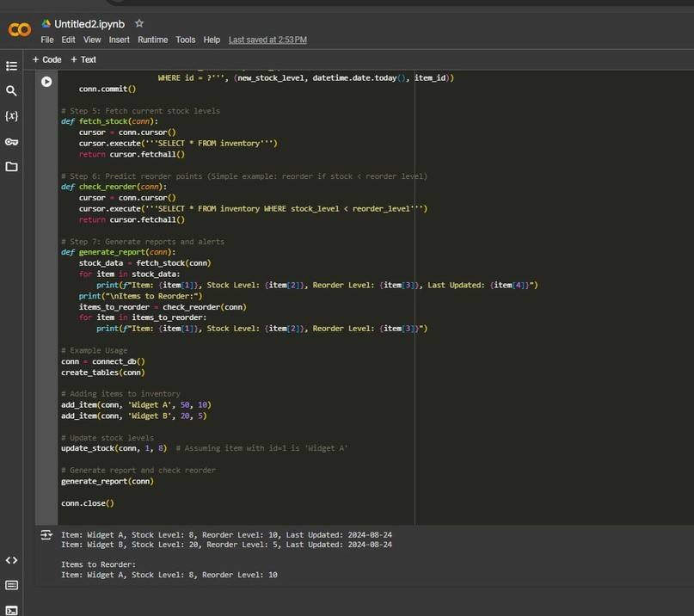

The system should allow users to:

* Add new inventory items.
* Update stock levels.
* View current inventory.
* Receive alerts for items that need to be reordered.

**5.Documentation:**

* ThisprojectdoesnotuseanexternalAPI.Instead,itusesalocalSQLitedatabasetomanage inventory data.
* DatabaseOperations:Createtables,additems,updatestock,fetchstock,checkreorderpoints, and generate reports.
* Manage database interactions and generate user-friendly outputs.
* The data base is local and does not require network connections.
* Inventory data is manually managed by the user.
* Implementmachinelearningalgorithmstopredictfutureinventoryneedsbased on historical data.
* Enhancetheuserinterfacewithagraphicaluserinterface(GUI)foreasierdatamanagement.
* Integratewithexternalsystems(e.g.,salesplatforms)forautomatedstockupdates.